[Date]

Hello [Applicant Name],

As part of your consideration for volunteer assignment, you will need to fill out the background questionnaire found at the link below.

Click here to begin

The background questionnaire takes approximately 15 minutes to complete and we recommend that you double check the information you provide for accuracy to make sure there is no delay in processing your background investigation.

To remain in active consideration for volunteer assignment, you must complete the background questionnaire within [Days Email Active] days.

Thank you,

[Client Name]  
[Client Email]  
[Client Phones]

This email is intended only for the person or entity to which it is addressed and may contain information that is privileged, confidential, or otherwise protected from disclosure. Dissemination, distribution, or copying of this e-mail or the information herein by anyone other than the intended recipient, or by an employee or agent responsible for delivering the message to the intended recipient, is prohibited. If you have received this e-mail in error, please notify us immediately by replying to the sender.

[Date]

Hello [Applicant Name],

This is a reminder that you have not yet completed the background questionnaire. To begin, please click on the link below.

Click here to begin

If you have any questions, please contact us using the information below.

Thank you,

[Client Name]  
[Client Email]  
[Client Phone

[Date]

Hello [Applicant Name],

Thank you for filling out our background questionnaire. **Your file number is [File Number]**. Use this number when referring to your background screening report. If you have any questions regarding next steps, please contact us using the information below.

Thank you,

[Client Name]  
[Client Email]  
[Client Phones]

NOTE: If you have any questions regarding your background screening report, please contact the background screening agency below.

[CRA Name]  
[CRA Phones]  
[CRA Address]

*This email is intended only for the person or entity to which it is addressed and may contain information that is privileged, confidential, or otherwise protected from disclosure. Dissemination, distribution, or copying of this e-mail or the information herein by anyone other than the intended recipient, or by an employee or agent responsible for delivering the message to the intended recipient, is prohibited. If you have received this e-mail in error, please notify us immediately by replying to the sender.*

Hello [Applicant Name],

This is to inform you that your credit card has been charged a total of [Charge Amount]. This is in accordance with the background questionnaire you filled out with [Client Name]. A confirmation number for that order was given to you at that time. Please refer to it if you need to contact [Client Name] for whatever reason. Also, if you have questions regarding your consumer report, please contact our Consumer Report Agency (CRA), [CRA Name].

[Client Name]  
[Client Address]  
[Client Phone]

----------------------------------------

[CRA Name]  
[CRA Address]  
[CRA Phone]

*This email is intended only for the person or entity to which it is addressed and may contain information that is privileged, confidential, or otherwise protected from disclosure. Dissemination, distribution, or copying of this e-mail or the information herein by anyone other than the intended recipient, or by an employee or agent responsible for delivering the message to the intended recipient, is prohibited. If you have received this e-mail in error, please notify us immediately by replying to the sender*

# **Welcome!**

# **Are you ready to begin the background check process?**

Once you start, you will complete the following steps:

* Give consent to running your background check electronically.
* Complete the necessary legal process.
* Fill out the background questionnaire.
* Submit your information.

Do not click the back button during this process. You will have the opportunity to edit the information you provide before submitting your questionnaire.

**ELECTRONIC SIGNATURE CONSENT**

As part of the selection process at [Client Name] (the "Company") you will need to consent to a background check electronically. By typing your name and clicking in the box below, you are consenting to receive any communications (legally required or otherwise) and all changes to such communications electronically. In order to use the website, you must provide at your own expense an Internet connected device that is compatible with the minimum requirements outlined below. You also confirm that your device will meet these specifications and requirements and will permit you to access and retain the communications electronically each time you access and use the website.

**System Requirements to Access Information**

To receive and view an electronic copy of the Communications you must have the following equipment and software:

* A personal computer or other device which is capable of accessing the Internet. Your access to this page verifies that your system/device meets these requirements.
* A current version of Chrome, Firefox, Safari, or Microsoft Edge Internet web browser which supports security industry best practices for HTTPS encrypted communications, JavaScript, and cookies. Your access to this page verifies that your browser meets these requirements.

**System Requirements to Retain Information**

To retain a copy, you must either have a printer connected to your personal computer or other device or, alternatively, the ability to save a copy through use of printing service or software such as Adobe Acrobat. If you would like to proceed using paper forms, please choose option 2 below.

**Withdrawal of Electronic Acceptance of Disclosures and Notices**

You can also contact us to withdraw your consent to receive any future communications electronically, including if the system requirements described above change and you no longer possess the required system. If you withdraw your consent, we will terminate your use of the [CRA Name] website and the services provided through the [CRA Name] website.

To ensure that a signature is unique and to safeguard you against unauthorized use of your name, your IP address ([Applicant IP Address]) has been recorded and will be stored along with your electronic signature. Please note that if you wish to submit your Disclosure and Authorization Forms electronically, [CRA Name] requires that you include your social security number or user identification. All of your information will be encrypted and transmitted via our secure website.

**CHOOSE ONE OF THE FOLLOWING OPTIONS:**

Opt-in

I, [Applicant Name Input Field] (type full name), consent to transacting electronically, including receiving legally required notices electronically. I understand that [CRA Name] uses computer technology to ensure that my signed documents are not altered after submission. I agree to allow [CRA Name] to validate my signed documents in this way.

Opt-out

I, [Applicant Name Input Field] (type full name), **do not** wish to electronically sign my documents. Rather, I prefer to print out and sign paper versions of the documents and return them by mail or in person to the Company. I understand this may delay the selection process with the Company.

I certify that I am an individual seeking prospective or continued volunteer assignment in [ --Please Select-- V].

***(If California is selected the following appears:)***

Are you an individual seeking prospective or continued volunteer assignment in San Francisco, California?

Yes    No

Are you an individual seeking prospective or continued volunteer assignment in Los Angeles, California?

Yes    No

I certify that I am a resident of [ --Please Select-- V].

***(If California is selected the following appears:)***

Are you a resident of San Francisco, California? Yes    No

Are you a resident of Los Angeles, California? Yes    No

**DISCLOSURE REGARDING   
BACKGROUND INVESTIGATION**

[Client Name] (the "Company") may obtain a “consumer report” about you from a consumer reporting agency for volunteer assignment purposes. A “consumer report” is a background screening report that may contain information regarding your criminal history, sex offender registry status, credit history, social security number, motor vehicle records ("driving records"), education and employment history, professional licenses, or other information about you. The information in a “consumer report” may bear upon your character, general reputation, personal characteristics, and/or mode of living.

***Para información en español, visite***[***www.consumerfinance.gov/learnmore***](http://www.consumerfinance.gov/learnmore)***o escribe a la Consumer Financial Protection Bureau, 1700 G Street N.W., Washington, DC 20552.***

**A Summary of Your Rights Under the Fair Credit Reporting Act**

The federal Fair Credit Reporting Act (FCRA) promotes the accuracy, fairness, and privacy of information in the files of consumer reporting agencies. There are many types of consumer reporting agencies, including credit bureaus and specialty agencies (such as agencies that sell information about check writing histories, medical records, and rental history records). Here is a summary of your major rights under the FCRA. **For more information, including information about additional rights, go to**[**www.consumerfinance.gov/learnmore**](http://www.consumerfinance.gov/learnmore)**or write to: Consumer Financial Protection Bureau, 1700 G Street N.W., Washington, DC 20552.**

* **You must be told if information in your file has been used against you.** Anyone who uses a credit report or another type of consumer report to deny your application for credit, insurance, or employment - or to take another adverse action against you - must tell you, and must give you the name, address, and phone number of the agency that provided the information.
* **You have the right to know what is in your file.** You may request and obtain all the information about you in the files of a consumer reporting agency (your "file disclosure"). You will be required to provide proper identification, which may include your Social Security number. In many cases, the disclosure will be free. You are entitled to a free file disclosure if:
  + a person has taken adverse action against you because of information in your credit report;
  + you are the victim of identity theft and place a fraud alert in your file;
  + your file contains inaccurate information as a result of fraud;
  + you are on public assistance;
  + you are unemployed but expect to apply for employment within 60 days.

In addition, all consumers are entitled to one free disclosure every 12 months upon request from each nationwide credit bureau and from nationwide specialty consumer reporting agencies. See [www.consumerfinance.gov/learnmore](http://www.consumerfinance.gov/learnmore) for additional information.

* **You have the right to ask for a credit score.** Credit scores are numerical summaries of your credit-worthiness based on information from credit bureaus. You may request a credit score from consumer reporting agencies that create scores or distribute scores used in residential real property loans, but you will have to pay for it. In some mortgage transactions, you will receive credit score information for free from the mortgage lender.
* **You have the right to dispute incomplete or inaccurate information.** If you identify information in your file that is incomplete or inaccurate, and report it to the consumer reporting agency, the agency must investigate unless your dispute is frivolous. See [www.consumerfinance.gov/learnmore](http://www.consumerfinance.gov/learnmore) for an explanation of dispute procedures.
* **Consumer reporting agencies must correct or delete inaccurate, incomplete, or unverifiable information.** Inaccurate, incomplete, or unverifiable information must be removed or corrected, usually within 30 days. However, a consumer reporting agency may continue to report information it has verified as accurate.
* **Consumer reporting agencies may not report outdated negative information.** In most cases, a consumer reporting agency may not report negative information that is more than seven years old, or bankruptcies that are more than 10 years old.
* **Access to your file is limited.** A consumer reporting agency may provide information about you only to people with a valid need -- usually to consider an application with a creditor, insurer, employer, landlord, or other business. The FCRA specifies those with a valid need for access.
* **You must give your consent for reports to be provided to employers.** A consumer reporting agency may not give out information about you to your employer, or a potential employer, without your written consent given to the employer. Written consent generally is not required in the trucking industry. For more information, go to [www.consumerfinance.gov/learnmore](http://www.consumerfinance.gov/learnmore).
* **You may limit "prescreened" offers of credit and insurance you get based on information in your credit report.** Unsolicited "prescreened" offers for credit and insurance must include a toll-free phone number you can call if you choose to remove your name and address from the lists these offers are based on. You may opt out with the nationwide credit bureaus at 1-888-5-OPTOUT (1-888-567-8688).
* The following FCRA right applies with respect to nationwide consumer reporting agencies:

**Consumers Have the Right To Obtain a Security Freeze**

**You have a right to place a "security freeze" on your credit report, which will prohibit a consumer reporting agency from releasing information in your credit report without your express authorization.** The security freeze is designed to prevent credit, loans, and services from being approved in your name without your consent. However, you should be aware that using a security freeze to take control over who gets access to the personal and financial information in your credit report may delay, interfere with, or prohibit the timely approval of any subsequent request or application you make regarding a new loan, credit, mortgage, or any other account involving the extension of credit.

As an alternative to a security freeze, you have the right to place an initial or extended fraud alert on your credit file at no cost. An initial fraud alert is a 1-year alert that is placed on a consumer's credit file. Upon seeing a fraud alert display on a consumer's credit file, a business is required to take steps to verify the consumer's identity before extending new credit. If you are a victim of identity theft, you are entitled to an extended fraud alert, which is a fraud alert lasting 7 years.

A security freeze does not apply to a person or entity, or its affiliates, or collection agencies acting on behalf of the person or entity, with which you have an existing account that requests information in your credit report for the purposes of reviewing or collecting the account. Reviewing the account includes activities related to account maintenance, monitoring, credit line increases, and account upgrades and enhancements.

* **You may seek damages from violators.** If a consumer reporting agency, or, in some cases, a user of consumer reports or a furnisher of information to a consumer reporting agency violates the FCRA, you may be able to sue in state or federal court.
* **Identity theft victims and active duty military personnel have additional rights.** For more information, visit [www.consumerfinance.gov/learnmore](http://www.consumerfinance.gov/learnmore).

**States may enforce the FCRA, and many states have their own consumer reporting laws. In some cases, you may have more rights under state law. For more information, contact your state or local consumer protection agency or your state Attorney General. For information about your federal rights, contact:**

|  |  |
| --- | --- |
| **TYPE OF BUSINESS:** | **CONTACT:** |
| 1.a. Banks, savings associations, and credit unions with total assets of over $10 billion and their affiliates  b. Such affiliates that are not banks, savings associations, or credit unions also should list, in addition to the CFPB: | a. Consumer Financial Protection Bureau 1700 G Street, N.W. Washington, DC 20552  b. Federal Trade Commission Consumer Response Center 600 Pennsylvania Avenue, N.W. Washington, DC 20580 (877) 382-4357 |
| 2. To the extent not included in item 1 above: a. National banks, federal savings associations, and federal branches and federal agencies of foreign banks  b. State member banks, branches and agencies of foreign banks (other than federal branches, federal agencies, and Insured State Branches of Foreign Banks), commercial lending companies owned or controlled by foreign banks, and organizations operating under section 25 or 25A of the Federal Reserve Act.  c. Nonmember Insured Banks, Insured State Branches of Foreign Banks, and insured state savings associations  d. Federal Credit Unions | a. Office of the Comptroller of the Currency Customer Assistance Group 1301 McKinney Street, Suite 3450 Houston, TX 77010-9050  b. Federal Reserve Consumer Help Center P.O. Box. 1200 Minneapolis, MN 55480  c. FDIC Consumer Response Center 1100 Walnut Street, Box #11 Kansas City, MO 64106  d. National Credit Union Administration Office of Consumer Financial Protection (OCFP) Division of Consumer Compliance Policy and Outreach 1775 Duke Street Alexandria, VA 22314 |
| 3. Air carriers | Asst. General Counsel for Aviation Enforcement & Proceedings Aviation Consumer Protection Division Department of Transportation 1200 New Jersey Avenue, S.E. Washington, DC 20590 |
| 4. Creditors Subject to the Surface Transportation Board | Office of Proceedings, Surface Transportation Board Department of Transportation 395 E Street, S.W. Washington, DC 20423 |
| 5. Creditors Subject to the Packers and Stockyards Act, 1921 | Nearest Packers and Stockyards Administration area supervisor |
| 6. Small Business Investment Companies | Associate Deputy Administrator for Capital Access United States Small Business Administration 409 Third Street, S.W., Suite 8200 Washington, DC 20416 |
| 7. Brokers and Dealers | Securities and Exchange Commission 100 F Street, N.E. Washington, DC 20549 |
| 8. Federal Land Banks, Federal Land Bank Associations, Federal Intermediate Credit Banks, and Production Credit Associations | Farm Credit Administration 1501 Farm Credit Drive McLean, VA 22102-5090 |
| 9. Retailers, Finance Companies, and All Other Creditors Not Listed Above | Federal Trade Commission Consumer Response Center 600 Pennsylvania Avenue, N.W. Washington, DC 20580 (877) 382-4357 |

**DISCLOSURE FOR INVESTIGATIVE   
CONSUMER REPORT**

[Client Name] (the "Company") may also request an “investigative consumer report” on you from a consumer reporting agency.

An “investigative consumer report” is a background check report generated through personal interviews with sources such as your neighbors, friends or associates. The information contained in an “investigative consumer report” may bear upon about your character, general reputation, personal characteristics, and/or mode of living.

The consumer reporting agency that may prepare an “investigative consumer report” on you for the Company is **[CRA Name], [CRA Phones], [CRA Address].**

Please be advised that the nature and scope of the investigative consumer report that may be ordered by the Company is an investigation into your employment history. During such an investigation **[CRA Name]** may ask questions about your employment history to certain knowledgeable individuals and provide response information to the Company.

**Note: You have the right to request disclosure of further information regarding the nature and scope of any investigative consumer report ordered by the Company on you.** You may do so by contacting the Company. You should carefully consider whether to exercise your right to request further information regarding the nature and scope of any investigative consumer report.

|  |
| --- |
| **City of Los Angeles** CALIFORNIA |
|  |
|   ERIC GARCETTI MAYOR |
|  |

**NOTICE TO APPLICANTS & EMPLOYEES  
FAIR CHANCE INITIATIVE FOR HIRING ORDINANCE**

This Employer is subject to the Fair Chance Initiative for Hiring Ordinance (FCIHO) (LAMC 189.00).

**THESE ARE YOUR RIGHTS...**

|  |  |  |
| --- | --- | --- |
| **1.** | **Employers cannot inquire about or seek information about an Applicant's Criminal History until after a Conditional Offer of Employment has been made to the Applicant*.** | |
|  |  |  | | |  |
|  |  | * This includes job solicitations and applications or during any conversations or interviews | |

|  |  |  |  |  |
| --- | --- | --- | --- | --- |
| **2.** | **If an Employer decides to rescind an offer of employment based on information discovered during the criminal background check, the Employer is required to perform an Individualized Assessment.** | | | |
|  |  |  |  | | |
|  |  | * Individualized Assessment - a written assessment that effectively links the specific aspects of the Applicant's Criminal History with risks inherent in the duties of the Employment position sought by the Applicant. | |
|  |  | * If the offer is rescinded, the Applicant must receive: | |
|  |  |  | * Written notification |
|  |  |  | * Copy of the Individualized Assessment, and |
|  |  |  | * Copies of any documentation used in the Employer’s decision |

|  |  |  |
| --- | --- | --- |
| **3.** | **The Applicant has the right to the Fair Chance Process.** | |
|  |  |  | |  |
|  |  | * The Applicant has the opportunity to provide information or documentation to an Employer regarding the accuracy of his/her Criminal History or Criminal History Report or that should be considered in the Employer's assessment, such as evidence of rehabilitation or other mitigating factors. |
|  |  | * The Employer is required to hold the job open for at least five (5) days from the date notification of a rescinded offer of employment to allow an Applicant to submit such documentation, and, the Employer is required to review any documentation in order to reassess their decision. |

FOR ADDITIONAL INFORMATION OR ASSISTANCE, CALL:  
City of Los Angeles  
Department of Public Works  
Office of Contract Compliance  
1149 S. Broadway Street, Suite 300  
Los Angeles, CA 90015  
Phone: (844) WagesLA – Email: WagesLA@lacity.org  
  
*Note: Not all Applicants/Employees are covered under the FCIHO. Please see ordinance (LAMC 189.00) for more details.

Form FCIHO, Rev. 12/1

**City of Los Angeles**

**CALIFORNIA**

**ERIC GARCETTI   
MAYOR**

**AVISO PARA SOLICITANTES Y EMPLEADOS   
ORDENANZA DE LA INICIATIVA DE OPORTUNIDAD JUSTA PARA LA**

**CONTRATACION**

Este empleador esta sujeto a la Ordenanza de Ia Iniciativa de Oportunidad Justa Para la Contrataci6n (Fair Chance Initiative for Hiring Ordinance) (FCIHO) (LAMC 189.00).

ESTOS SON SUS DERECHOS...

1. Los Empleadores no pueden preguntar al solicitante sabre los antecedentes penales hasta despOes de quo se Ic haya dado al Solicitante- una oferta condicional de empleo.

Esto incluye solicitaciones y solicitudes de empleo o durante cualquier tipo de conversaciones o entrevistas.

1. Si el Empleador decide rescindir Ia oferta de empleo como resultado de Ia investigation de antecedentes, el Empleador esta obligado a realizar una Evaluacion Individualizada.

* EvaivaciOn Individualizada un analisis por escnto de las funciones y responsabilidades del trabajo, los antecedentes penales del Solicitante y cualquier otro factores que pueden afectar a la decision de contrataciOn.
* Si se rescinde la oferta. el Solicitante debe reabir:

Un aviso por escrito.

Una copia de la Evaluacion Individual y

Copias de todos los documentos que el Empleador utilizO a Ilegar a la decision.

3. El solicitante tiene el derecho al proceso do **Ia** Oportunidad Justa.

* El Solicitante tiene la oportunidad de proporcionar informaciOn o documentaciOn a un Empleador con respecto a la exactitud de sus Antecedentes Penales. Dictios datos deben ser considerados en la evaluation del Empleador. como evidencia de rehabilitation u otros factores mitigadores.
* Se requiere que el Empleador mantenga el puesto abierto por lo menos cinco (5) dias laborales de la fecha de notification de la action adversa propuesta para perm& que el Solicitante presente tal documentation. El Empleador esta obligado revisar cualquier documentaciOn para reevaluar su decision.

PARA MAS INFORMACION 0 ASISTENCIA. PUEDE LLAMAR A_   
Dry of Los Angeles   
Department of Put./lc Works   
Office of Wage Standards   
1149 S. Broadway. Stale 300   
Los Angeles, CA 90015   
Te4Vono. 4844) WagesLA - [Email. WsgesLAalacity.org](http://Email.WsgesLAalacity.org)

*La nota. tockel Ice sodotantesJerripieados estan cubierto *bap* el FCIHO Consul& con la ordenaraa ILAMC 189.00) pa,a ma, dela le,

Form FCIHO. Rev. owl Et

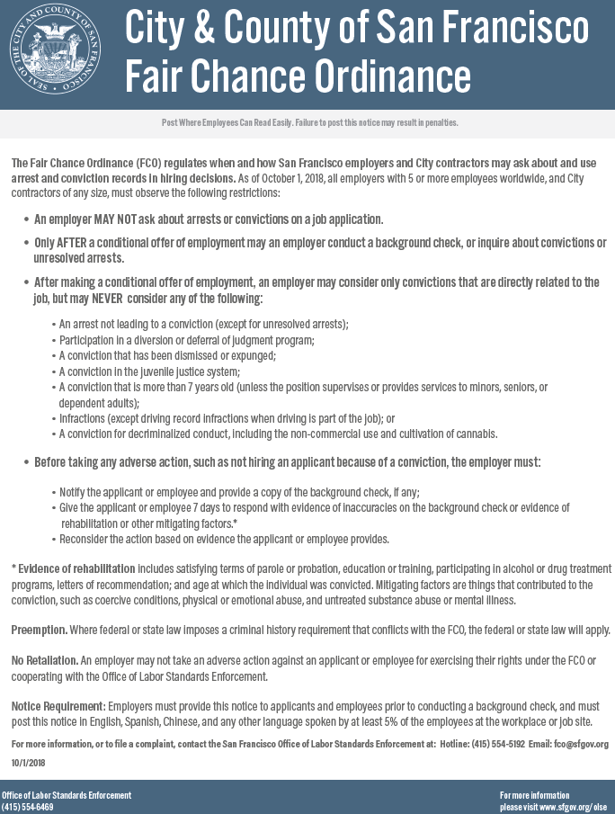

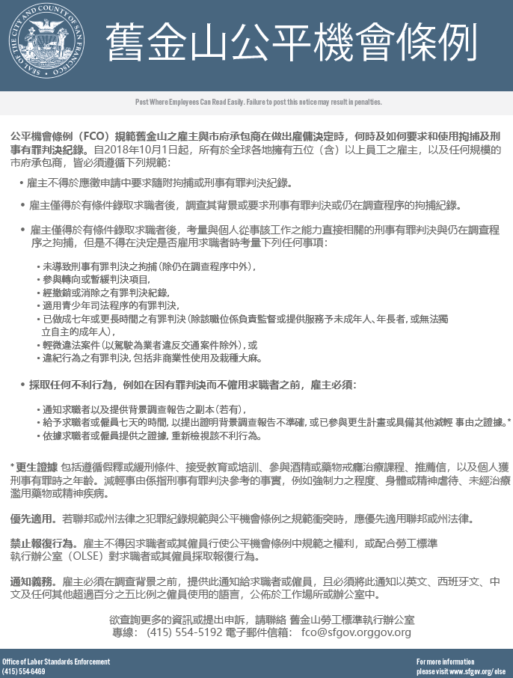

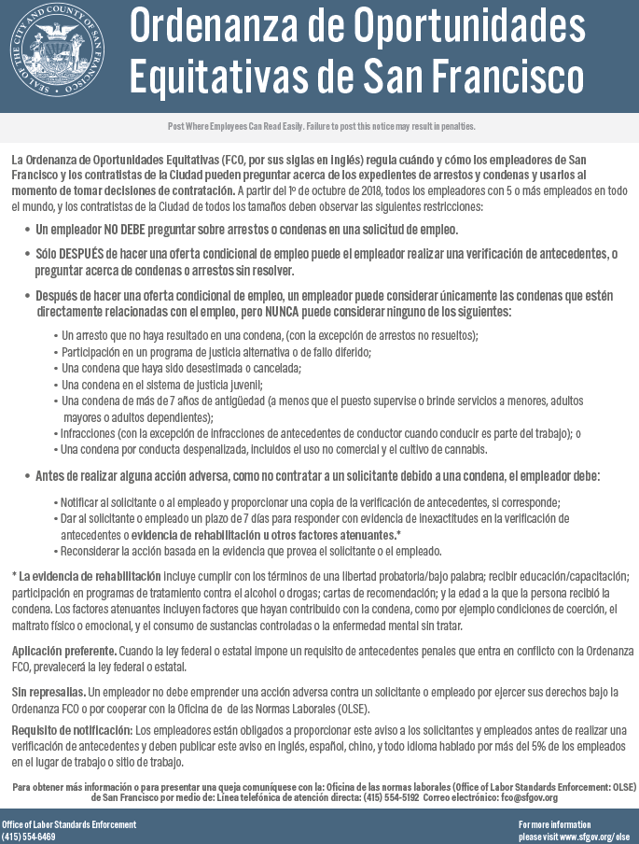

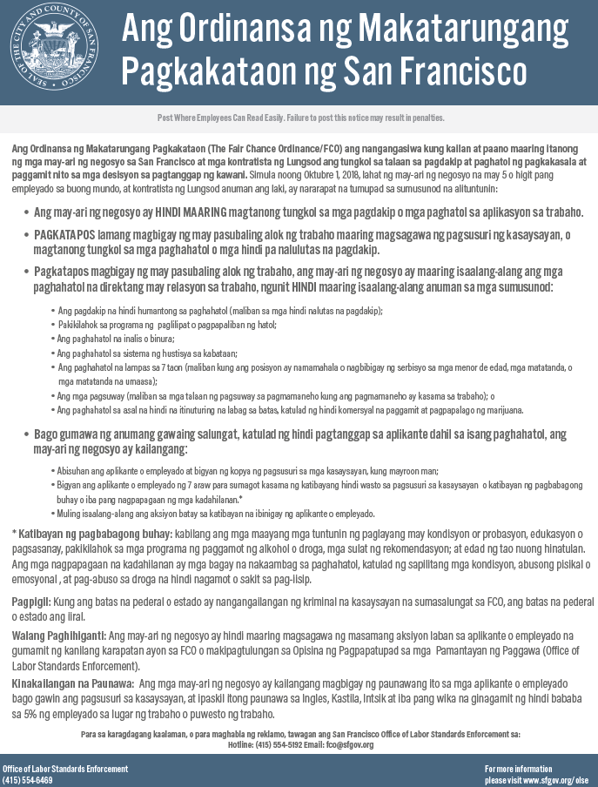

**NOTICE REGARDING BACKGROUND CHECKS  
PER CALIFORNIA LAW**

[Client Name] (the "Company") intends to obtain information about you for volunteer assignment purposes from an investigative consumer reporting agency. Thus, you can expect to be the subject of "investigative consumer reports" obtained for volunteer assignment purposes. Such reports may include information about your character, general reputation, personal characteristics and mode of living. With respect to any investigative consumer report from an investigative consumer reporting agency ("ICRA"), the Company may investigate the information contained in your volunteer application and other background information about you, including but not limited to obtaining criminal records, verifying references, work history, your social security number, your educational achievements, licensure, and certifications, your driving record, and other information about you, and interviewing people who are knowledgeable about you. The results of this report may be used as a factor in making volunteer assignment decisions. The source of any investigative consumer report (as that term is defined under California law) will be **[CRA Name], [CRA Phones], [CRA Address],** **[CRA Website]**.

Under California Civil Code section 1786.22, you are entitled to find out what is in the ICRA's file on you with proper identification, as follows:

* In person, by visual inspection of your file during normal business hours and on reasonable notice. You also may request a copy of the information in person. The ICRA may not charge you more than the actual copying costs for providing you with a copy of your file.
* A summary of all information contained in the ICRA's file on you that is required to be provided by the California Civil Code will be provided to you via telephone, if you have made a written request, with proper identification, for telephone disclosure, and the toll charge, if any, for the telephone call is prepaid by or charged directly to you.
* By requesting a copy be sent to a specified addressee by certified mail. ICRAs complying with requests for certified mailings shall not be liable for disclosures to third parties caused by mishandling of mail after such mailings leave the ICRAs.

"Proper Identification" includes documents such as a valid driver's license, social security account number, military identification card, and credit cards. Only if you cannot identify yourself with such information may the ICRA require additional information concerning your employment and personal or family history in order to verify your identity.

The ICRA will provide trained personnel to explain any information furnished to you and will provide a written explanation of any coded information contained in files maintained on you. This written explanation will be provided whenever a file is provided to you for visual inspection.

You may be accompanied by one other person of your choosing, who must furnish reasonable identification. An ICRA may require you to furnish a written statement granting permission to the ICRA to discuss your file in such person's presence.

 Please check this box if you would like to receive a copy of an investigative consumer report at no charge if one is obtained by the Company whenever you have a right to receive such a copy under California law.



**NOTICE REGARDING INVESTIGATIVE CONSUMER REPORTS PER MASSACHUSETTS LAW**

With your permission and pursuant to the Annotated Laws of Massachusetts, Chapter 93 § 53, [Client Name] (the "Company") may request from a consumer reporting agency an investigative consumer report in connection with your prospective or continued volunteer assignment. Such reports commonly include information as to your character, general reputation, personal characteristics or mode of living and involve obtaining information through personal interviews. The source of any investigative consumer report will be [CRA Name], [CRA Address], [CRA Website], [CRA Phones]. The nature and scope of any investigative consumer report requested by the Company will be as follows: interviewing people who are knowledgeable about you as to your work history. If the Company requests an investigative consumer report, you have the right to have a copy of the report upon request.

**NOTICE REGARDING CONSUMER   
REPORTS PER MINNESOTA LAW**

[Client Name] (the "Company") may obtain a consumer report from a consumer reporting agency in connection with your prospective or continued volunteer assignment. Such reports may contain information regarding your criminal history, sex offender registry status, social security number, motor vehicle records ("driving records"), education and employment history, professional licenses, or other information and may include information concerning your character, general reputation, personal characteristics or mode of living. These reports may also include investigative consumer report information, which is information obtained through personal interviews. The investigative consumer report that may be obtained by the Company is a reference check through personal interviews with sources such as your former employers and associates, and other information sources. You have the right, upon written request, to receive a complete and accurate disclosure of the nature and scope of any consumer report ordered by the Company. A consumer reporting agency must make this disclosure within five (5) days of receipt of your request or of the Company’s request for the report, whichever is later.

**NOTICE REGARDING INVESTIGATIVE CONSUMER REPORTS PER NEW JERSEY LAW**

With your permission, [Client Name] (the "Company") may order from a consumer reporting agency an investigative consumer report, which commonly includes information regarding your character, general reputation, personal characteristics or mode of living and involves obtaining information through personal interviews. The precise nature and scope of any investigative consumer report requested by the Company will be as follows: interviewing people who are knowledgeable about you as to your work history.

The source of any investigative consumer report will be [CRA Name], [CRA Address], [CRA Website], [CRA Phones]. If the Company requests an investigative consumer report, you have the right to have a copy of the report upon request.

**NEW YORK CORRECTION LAW ARTICLE 23-A**

**LICENSURE AND EMPLOYMENT OF PERSONS PREVIOUSLY CONVICTED OF ONE OR MORE CRIMINAL OFFENSES**

**Section 750. Definitions.**

**751. Applicability.**

**752. Unfair discrimination against persons previously convicted of one or more criminal offenses prohibited.**

**753. Factors to be considered concerning a previous criminal conviction; presumption.**

**754. Written statement upon denial of license or employment.**

**755. Enforcement.**

**§750. Definitions.** For the purposes of this article, the following terms shall have the following meanings:

(1) "Public agency" means the state or any local subdivision thereof, or any state or local department, agency, board or commission.

(2) "Private employer" means any person, company, corporation, labor organization or association which employs ten or more persons.

(3) "Direct relationship" means that the nature of criminal conduct for which the person was convicted has a direct bearing on his fitness or ability to perform one or more of the duties or responsibilities necessarily related to the license, opportunity, or job in question.

(4) "License" means any certificate, license, permit or grant of permission required by the laws of this state, its political subdivisions or instrumentalities as a condition for the lawful practice of any occupation, employment, trade, vocation, business, or profession. Provided, however, that "license" shall not, for the purposes of this article, include any license or permit to own, possess, carry, or fire any explosive, pistol, handgun, rifle, shotgun, or other firearm.

(5) "Employment" means any occupation, vocation or employment, or any form of vocational or educational training. Provided, however, that "employment" shall not, for the purposes of this article, include membership in any law enforcement agency.

**§751. Applicability.** The provisions of this article shall apply to any application by any person for a license or employment at any public or private employer, who has previously been convicted of one or more criminal offenses in this state or in any other jurisdiction, and to any license or employment held by any person whose conviction of one or more criminal offenses in this state or in any other jurisdiction preceded such employment or granting of a license, except where a mandatory forfeiture, disability or bar to employment is imposed by law, and has not been removed by an executive pardon, certificate of relief from disabilities or certificate of good conduct. Nothing in this article shall be construed to affect any right an employer may have with respect to an intentional misrepresentation in connection with an application for employment made by a prospective employee or previously made by a current employee.

**§752. Unfair discrimination against persons previously convicted of one or more criminal offenses prohibited.** No application for any license or employment, and no employment or license held by an individual, to which the provisions of this article are applicable, shall be denied or acted upon adversely by reason of the individual's having been previously convicted of one or more criminal offenses, or by reason of a finding of lack of "good moral character" when such finding is based upon the fact that the individual has previously been convicted of one or more criminal offenses, unless:

(1) There is a direct relationship between one or more of the previous criminal offenses and the specific license or employment sought or held by the individual; or

(2) the issuance or continuation of the license or the granting or continuation of the employment would involve an unreasonable risk to property or to the safety or welfare of specific individuals or the general public.

**§753. Factors to be considered concerning a previous criminal conviction; presumption.** 1. In making a determination pursuant to section seven hundred fifty-two of this chapter, the public agency or private employer shall consider the following factors:

(a) The public policy of this state, as expressed in this act, to encourage the licensure and employment of persons previously convicted of one or more criminal offenses.

(b) The specific duties and responsibilities necessarily related to the license or employment sought or held by the person.

(c) The bearing, if any, the criminal offense or offenses for which the person was previously convicted will have on his fitness or ability to perform one or more such duties or responsibilities.

(d) The time which has elapsed since the occurrence of the criminal offense or offenses.

(e) The age of the person at the time of occurrence of the criminal offense or offenses.

(f) The seriousness of the offense or offenses.

(g) Any information produced by the person, or produced on his behalf, in regard to his rehabilitation and good conduct.

(h) The legitimate interest of the public agency or private employer in protecting property, and the safety and welfare of specific individuals or the general public.

2. In making a determination pursuant to section seven hundred fifty-two of this chapter, the public agency or private employer shall also give consideration to a certificate of relief from disabilities or a certificate of good conduct issued to the applicant, which certificate shall create a presumption of rehabilitation in regard to the offense or offenses specified therein.

**§754. Written statement upon denial of license or employment.** At the request of any person previously convicted of one or more criminal offenses who has been denied a license or employment, a public agency or private employer shall provide, within thirty days of a request, a written statement setting forth the reasons for such denial.

**§755. Enforcement.** 1. In relation to actions by public agencies, the provisions of this article shall be enforceable by a proceeding brought pursuant to article seventy-eight of the civil practice law and rules.

2. In relation to actions by private employers, the provisions of this article shall be enforceable by the division of human rights pursuant to the powers and procedures set forth in article fifteen of the executive law, and, concurrently, by the New York city commission on human rights.

**NOTICE REGARDING INVESTIGATIVE CONSUMER REPORTS PER NEW YORK LAW**

With your permission and pursuant to New York General Business Law § 380, [Client Name] (the "Company") may request an investigative consumer report about you from a third party consumer reporting agency, in connection with your volunteer assignment or application for volunteer assignment. An "investigative consumer report" is a background report that includes information from personal interviews. The most common form of an investigative consumer report in connection with your volunteer assignment is a reference check through personal interviews with sources such as your former employers and associates, and other information sources. The investigative consumer report may contain information concerning your character, general reputation, personal characteristics or mode of living. You may request more information about whether or not an investigative consumer report was requested, as well as information on the nature and scope of an investigative consumer report, if any, by contacting the Company in writing.

You have the right to receive a copy of any investigative consumer report requested by the Company, upon its completion, by contacting the following consumer reporting agency:

[CRA Name]  
[CRA Address]  
[CRA Phones]  
[CRA Website]

**NOTICE REGARDING CONSUMER   
REPORTS PER OKLAHOMA LAW**

Pursuant to 24 Oklahoma Statutes § 148, [Client Name] (the "Company") will request or order a consumer report from a consumer reporting agency to be used in connection with your potential or continued volunteer assignment. Such a report may contain information regarding your criminal history, sex offender registry status, social security number, motor vehicle records, education and employment history, professional licenses, or other information about you. You have the right, upon request, to receive a copy of any consumer report requested by the Company for this purpose.

**NOTICE REGARDING INVESTIGATIVE CONSUMER REPORTS PER WASHINGTON LAW**

In connection with your prospective or continued volunteer assignment, [Client Name] (the "Company") may request an investigative consumer report from a consumer reporting agency, which may include information as to your character, general reputation, personal characteristics or mode of living. An "investigative consumer report" is a background report that includes information from personal interviews. The investigative consumer report that may be obtained by the Company is a reference check through personal interviews with sources such as your former employers and associates, and other information sources.

You may request a complete and accurate disclosure of the nature and scope of any investigation conducted. You may also request a written summary of your rights under the Washington Fair Credit Reporting Act.

The source of any investigative consumer report will be [CRA Name], [CRA Address], [CRA Website], [CRA Phones].

**ACKNOWLEDGMENT AND AUTHORIZATION  
FOR BACKGROUND CHECK**

I acknowledge receipt of the separate documents entitled DISCLOSURE REGARDING BACKGROUND INVESTIGATION ON YOU, A SUMMARY OF YOUR RIGHTS UNDER THE FAIR CREDIT REPORTING ACT and the DISCLOSURE REGARDING INVESTIGATIVE CONSUMER REPORT. I also acknowledge receipt of any applicable state or municipal law notices. I certify that I have read and understand those documents.

I authorize[Client Name](“the Company”)to obtain “consumer reports” and “investigative consumer reports” about me at any time during the hiring process and throughout my volunteer assignment, if applicable. I understand that such reports will be prepared by the following consumer reporting agency: [CRA Name], [CRA Address], [CRA Website], [CRA Phones].

To enable [CRA Name] to complete the above reports about me for the Company, I hereby authorize, any law enforcement agency, administrator, state or federal agency, institution, school or university (public or private), information service bureau, employer, or other party to furnish information about me to [CRA Name].

I further authorize the Company to share the information contained in the report(s) obtained about me with any third-party companies for which I will perform assignments for the Company or to which I will be given property access in connection with my work for the Company.

**Please check this box to receive a copy of any report furnished by [CRA Name] to the Company.**



|  |  |
| --- | --- |
| I AGREE  Type Name: | Last 4 of your social security number / user PIN: |
| **Please note: the last four digits of your SSN or user PIN may be required at a later time for verification purposes.** | |

**INTERNATIONAL DISCLOSURE AND**

**AUTHORIZATION REGARDING BACKGROUND**

**INVESTIGATION**

I understand that [Client Name] (the "Company") will be using [CRA Name], [CRA Contact Address], [CRA Website], [CRA Phones With Toll-Free and Fax] (the "Agency") and its agents as part of its procedure for processing my application for volunteer assignment and verifying certain background information about me.

I understand the Agency or its agents will carry out a background check about me on the Company's behalf in connection with my application for volunteer assignment or ongoing volunteer assignment with the Company and I consent to these background checks being made. I agree to assist the Agency and the Company and their agents in verifying and collecting this information and to provide any additional information requested in connection with my application for volunteer assignment with the Company or completing any specialized forms that may be required in connection with the background checks.

I understand that the background checks, to the extent applicable, will be conducted and information I provide will be researched and verified using any source deemed appropriate. In connection with this request I authorize all governmental agencies, private agencies and current and previous employers anywhere in the world to release information they may have including, but not limited to, the following: verification of current and past employment, criminal records, motor vehicle and driving records, credit records, military records, school/educational records, professional and personal references, and social media records. I further authorize the transfer of this information about me to the Agency or its agents and for the Agency to transfer such information to the Company, which may be located in the United States or another country. I understand the data protection laws in the United States and other countries where my personal information may be transferred may not provide the same level of protection as the laws in the country where I reside.

I understand that the processing and storage of sensitive personal data about me may include sensitive personal data for the purposes of the European Union's General Data Protection Regulation (GDPR), Mexico's Federal Law on the Protection of Personal Data held by Private Parties, Brazil's Law for the General Protection of Data (LGPD) or other applicable data protection laws. I understand that all information acquired by the Agency and its affiliates will be treated as strictly confidential and will only be used for the purposes that it is collected and for applicable regulatory purposes. I also understand that all data will be maintained by the Agency on a server in the United States subject to suitable safeguards. For additional information, contact [CRA Name], [CRA Contact Address], [CRA Website], [CRA Phones With Toll-Free and Fax].

I understand that the information collected by the the Agency to prepare the background checks will be retained for five years unless longer retention is required by law and that the Company will retain the information it receives from the Agency with its own retention policies.

I understand that I may withdraw my authorization to conduct background checks at any time. I recognize that if I decline to provide my authorization for the conduct of background checks or if I withdraw my consent, this may adversely affect my volunteer assignment opportunities with the Company, including making me ineligible to be assigned or for continued volunteer assignment.

I understand that to the extent authorized under the law applicable to me, I have certain rights as a data subject, which may include the right to access personal information about me, request the correction/rectification of such information, to request the deletion/cancellation of my personal information, to object to the processing of my personal information, and my right of data portability by contacting the Company or the Agency.

I further authorize any agent, to the extent required by any laws, rules applicable to any country, to provide the data pursuant to this authorization to governmental authorities in any country in connection with any regulatory filings it may submit to authorities.

**European Economic Area/United Kingdom/Swiss applicants:** The lawful basis for processing by the Agency, acting as a processor on behalf of the Company, is that processing is necessary for the purposes of the legitimate interests of the Company to evaluate the suitability of applicants and provide a safe workplace. I understand that I have a right to lodge a complaint with a supervisory authority if I do not believe my personal information is being processed appropriately.

**Mexico Applicants Only:** I acknowledge that I understand Advanced Reporting's Privacy Policy (available online at: <https://advrep.com/privacy-policy/>) regarding the handling of my personal information including the means to limit the use, disclosure or transfer of the data as well as protection of data during any electronic transfer; I also understand that I will be notified of any changes in the company's privacy policy that may relate to my personal background screen process.

**BY SIGNING BELOW, I HEREBY CERTIFY THAT THIS FORM WAS COMPLETED BY ME, THAT THE INFORMATION PROVIDED IS TRUE AND CORRECT AS OF THE DATE HEREOF. I understand that if I have made untrue statements or willfully been misleading in any answers given that this may lead to the withdrawal of any job offer or disciplinary action being taken against me by the Company.**

By signing below, I also authorize, without reservation, any individual, corporation or other private or public agency to provide the the Company and the Agency and their agents all relevant information about me of the types described above.

|  |  |
| --- | --- |
| I AGREE  Type Name: | Last 4 of your social security number / user PIN: |
| **Please note: the last four digits of your SSN or user PIN may be required at a later time for verification purposes.** | |

Hello,

Thank you for completing the background check questionnaire. You may wish to upload any documentation at this time that would assist with the background check. We may contact you at a later date to request additional items. Please retain your PIN number as it will be used to access our system for future requests and notifications.

Hello,

Thank you for completing the background check questionnaire. The background check requested by [Client - Name] may require additional information and/or documentation at this time. Please refer to the list below. If you are a current resident or provided previous address history in a country listed below, please upload the additional documentation and/or information. We may contact you at a later date to request additional items. Please retain your PIN number as it will be used to access our system for future requests and notifications.

*Note 1: If you do not see a country applicable to you below, that likely means that your name, date of birth and address information that you provided earlier is sufficient.

*Note 2: At this time, our system does not support uploaded files with a file name with non-English characters included. The file itself can include non-English characters, but not the file name. We apologize for the inconvenience.

Hello,

Thank you for completing the background check questionnaire. The screening requested by [Client - Name] includes retrieval of your Washington driving record. Please complete the provided Release of Interest document. We may contact you at a later date to request additional items. Please retain your PIN number as it will be used to access our system for future requests and notifications.

Thank you for completing your online background questionnaire. Your confirmation number is [File Number]. You may be asked for it if you need to contact [Client Name] at some future time. If you would like to print a copy of your Authorization or your Confirmation, please click on the appropriate button. If you have any questions regarding your consumer report, please contact our Consumer Report Agency (CRA), [CRA Name].